
Curriculum Vitae
Ali Akram Abdullah
Personal information
Name, Surname Ali, Abdullah
Birth date 02.02.1986
Birth place Baghdad / Iraq
Nationality Iraqi
Address Ghazaliyah, Baghdad, Iraq
Telephone +9647736774631
E-Mail engali_1986@yahoo.com

Qualifications
2004-2008

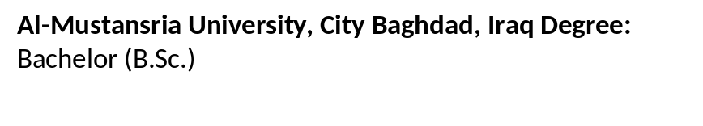

Awards
2008 In the 1st Quarter in Bachelor degree in Faculty of electrical Engineering /
Al-Mustansria University.

Practical experience
Location | Job title | Work period | Company
Baghdad –Karrada 62. st | Sales supervisior | 2008-2011 | Geze German International
Erbil-Makhmour St. | Sales manger | 2011-2013 | Vito Turkish CO.
Baghdad –Karrada-62 st. | Sales manger | 2013-2016 | AL-qasswa Co.(Perkins )
Baghdad –Karrada -Alarssat | Sales manger | 2017-2019 | Jisr Alfurat Co.
Languages
Arabic - Mother language English - Very Good

Computer Skills
- Professional in Microsoft Office (Word, Access, Excel, PowerPoint).

PERSONAL STATEMENT
A hard-working, knowledgeable and target-oriented Sales Manager with an extensive successful sales record. Builds and maintains a loyal client base through strong relationship-building skills, and excels at devising strategies for increased sales. Skilled in bringing out the best in staff; able to manage effectively and recruit talent. Strong organisational and time management ability; skilled in planning, scheduling and meeting deadlines. Driven to succeed; a valuable addition to a forward-thinking company with strong opportunities for progression.

